Measuring a Forest
Part A: Forested Area and Distribution
What percentage of the United States’ land area is covered in forest?
$$\frac{Part}{Whole}×100\%=$$
Shade in the areas you think are currently forested:
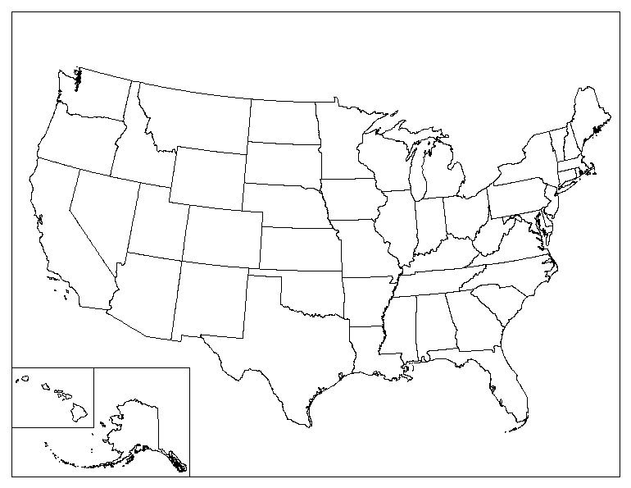
Biomass is: ___________________________________________________
Where are the areas of greatest forest biomass density in the United States?

Part B: Measuring Forests: Why and How
Name one reason why it’s important to measure and monitor forests:

A dendrologist is: ______________________________________________________
A tree’s crown is: ______________________________________________________
DBH is: ______________________________________________________________
Practice using C=πD (where C = circumference, D = diameter, and π ~ 3.14)
- D = 2, C = ?

- D = 6, C = ?

- D=1, C = ?

- C = 3.14, D = ?

- Radius (R) = 3, D = ?

- For every 1 inch increase in diameter, the circumference increases _____ inches.

What is the diameter of your tree cookie using a ruler? _________

What is the diameter of your tree cookie using DBH tape? _________

What is the diameter of your head? _________

Part C: Stand Density
Stand Density is: __________________________________________________________
Calculate the stand density of the example plot:

If everyone in this room were trees, what would be our stand density?

